CNC lathe project

**FINAL personal report**

Rosani Mujica

2017

**Table of content**

Introduction 1

Body 2

Recommendations 8

References 8

Bibliography 8

Appendix 9

# **Introduction**

The creation of this project could be useful as a reference for future project of automatization in the engineering field.

The scope of this project is to automate an old manual lathe machine with the objective to produce products that can be machine so much faster and safer for the machinist.

To undertake this project a list of task was produced to later identify the activities of each task. Once the task activities were identified, the next step is to assigned resources. Furthermore, a Gant chart was created to able the team to check if there were up-to-date.

In this report you will also find all the components necessary to install the X- axis shaft and its motor, accompanied with the detailed drawings of the parts that need to be fabricated.

# **Body**

My contribution to this project started drawing the saddle from the old lathe.

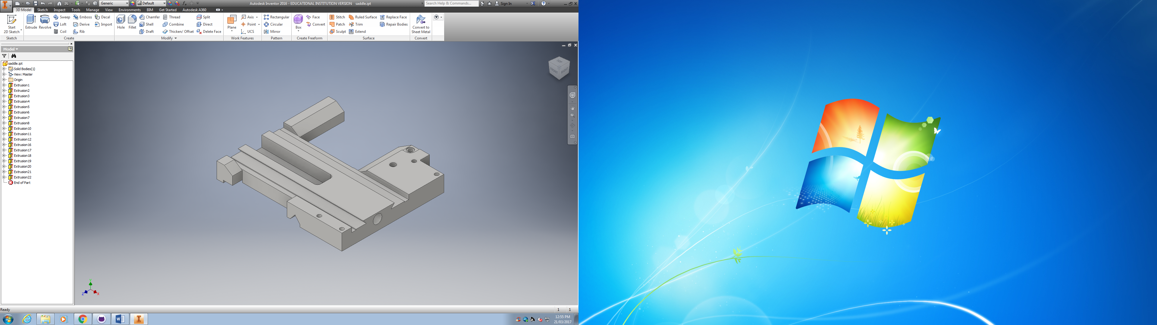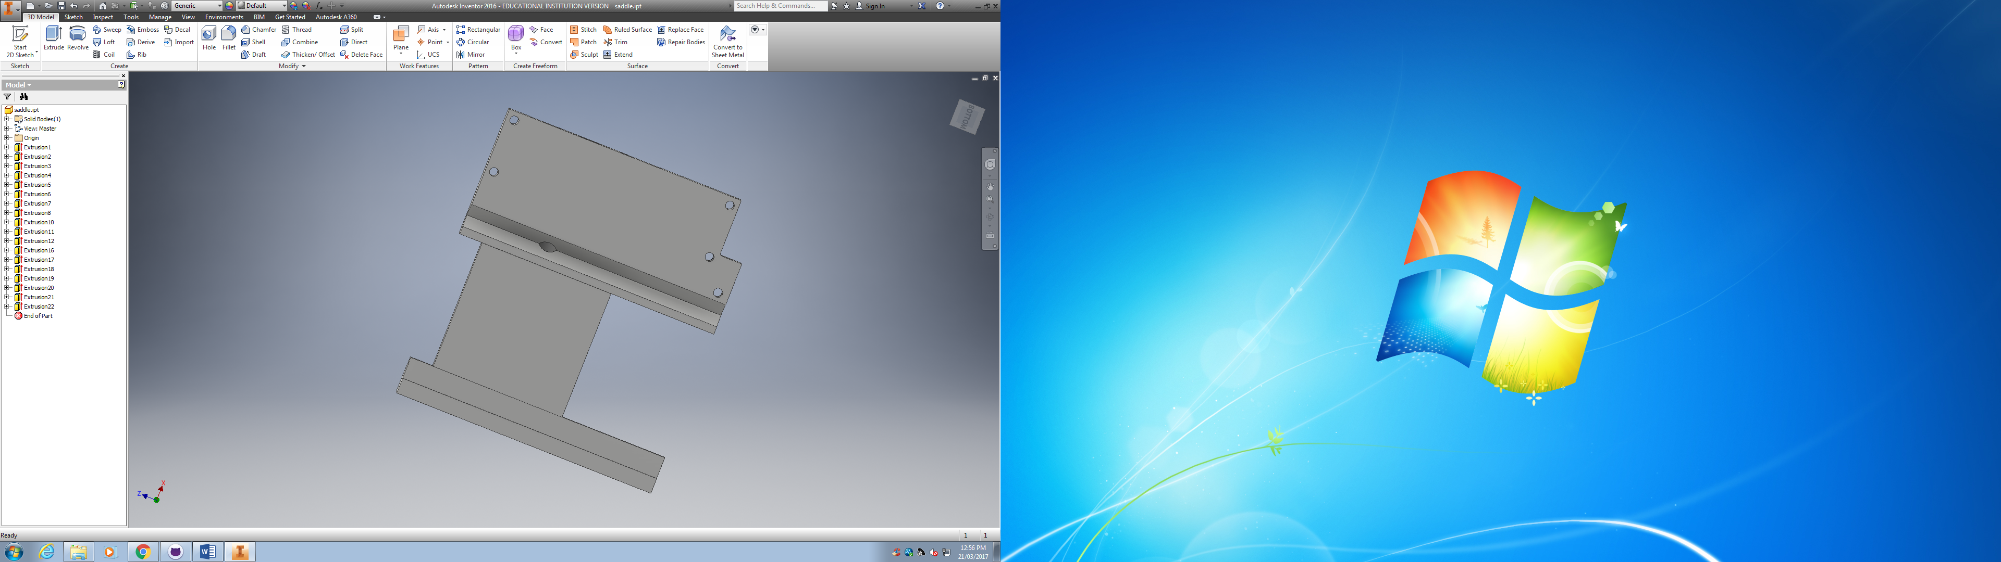

In order to execute this project, I created a ***Work Breakdown Structure*** (WBS) of the tasks that need to be undertaken to complete the project but before we did a brainstorming as a group so we do not miss details. So, the following tasks to execute this project are:

|  |
| --- |
| * **Pulling apart lathe** |
| * **Measuring parts** |
| * **Drawing parts in Inventor** |
| * **Searching information, calculations and selection** |
| * **Making shopping list** |
| * **Waiting for delivery of parts** |
| * **Designing supports of the screws, motors and sensors** |
| * **Designing protector cover for lathe** |
| * **Machining designed parts** |
| * **Cleaning lathe** |
| * **Painting lathe** |
| * **Installing new parts** |
| * **Electrical connections and installation** |
| * **Installing cover** |
| * **Risk mitigation analysis** |

However, this project it is done until the task “Designing protector cover for lathe”.

In order to assign the resources for each of the task, the task activities were described, which I later could assigned the resources in Microsoft Project software.

|  |  |
| --- | --- |
| **Tasks and** their activities | **Completed** |
| **Pulling apart lathe** |  |
| Disassemble carriage |  |
| Disassemble tail stock |  |
| Disassemble apron |  |
| Pull off gear box |  |
| Pull of motor |  |
| Disassemble safety cover |  |
| **Measuring parts** |  |
| saddle |  |
| tail stock |  |
| tail stock carriage |  |
| bed |  |
| tool post |  |
| under tool post |  |
| legs |  |
| apron |  |
| gear box |  |
| chuck |  |
| **Drawing parts in Inventor** |  |
| saddle |  |
| tail stock |  |
| tail stock carriage |  |
| bed |  |
| tool post |  |
| under tool post |  |
| legs |  |
| apron |  |
| gear box |  |
| chuck |  |
| **Searching information, calculation and selection** |  |
| Forces, speed, power |  |
| Ball screws |  |
| Servo motors |  |
| Cutting tools |  |
| Wiring diagram |  |
| Power board |  |
| Encoder |  |
| Sensors |  |
| **Monitoring** |  |
| **Safety** |  |
| End stops |  |
| Homing sensors |  |
| Encoder |  |
| **Mechanical axis of motion** |  |
| **Feed rate** |  |
| Ball screws -longitudinal Z |  |
| Cutting tool - across X |  |
| Spindle turning |  |
| **Motors** |  |
| Forces |  |
| Control |  |
| Voltage |  |
| **Making shopping list** |  |
| **Waiting for delivery of parts** |  |
| sensors |  |
| ball screws |  |
| Encoder |  |
| Servo motors |  |
| timing belts |  |
| wiring diagram |  |
| power board |  |
| control panels |  |
| **Designing supports of the screws, motors and sensors** |  |
| **Designing protector cover for lathe** |  |
| **Machining designed parts** |  |
| **Cleaning lathe** |  |
| **Painting lathe** |  |
| **Installing new parts** |  |
| **Electrical connections and installation** |  |
| **Installing cover** |  |
| **Risk mitigation analysis** |  |

Finally, with the help of Microsoft Project, the above tasks and their activities were listed in order to produce a Gant Chart (appendix 1), where I was able to assign dependencies, describe the resources necessary for the task and identify constraints. Once the dependencies and estimated times of the task were assigned in the software, an estimated duration of the project was obtained.

The next chart was the initial planning for the execution of this project, but of course as in any project delays are presented. Furthermore, for the schedule of this project was taken as working days Tuesday, 5 hours per day (9am to 3pm), 5 hours per week and 4 days per month.

According to dependencies and constraints, the project started on the 28th February 2017 and it supposes to be finished on the 27th June 2017.

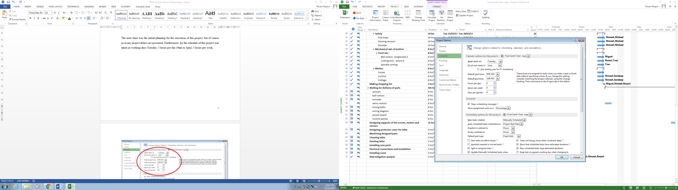

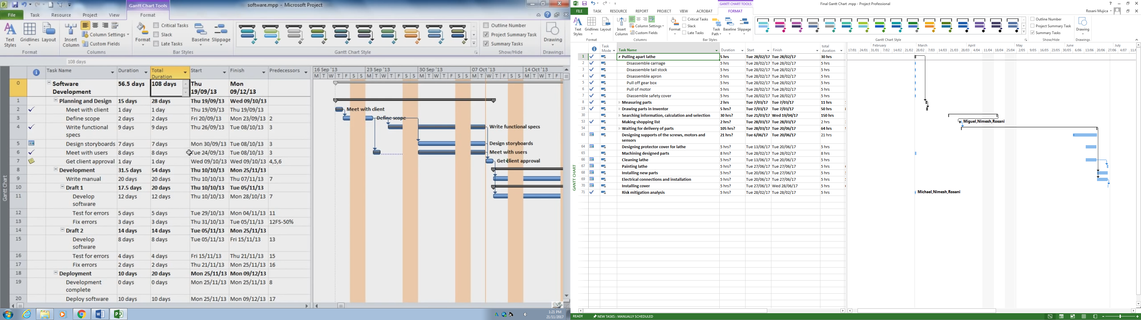

Total duration of the project: **305 hrs**

After all the tasks are described, another important aspect to consider in this project is Risk Analysis (appendix 2), which I performed with the help of Nimesh and Miguel.

My colleague Tran and I did all the analysis to assemble the X-axis: support, nut and the base support for the motor. To do so, we needed to move forward the tool post 20mm so we can have more travel distance of the cross slide and set the lathe to produce bigger diameters in the future.

To place the nut on the knee of the cross-slide it was to be machine due to there was not enough space, Furthermore to fix the nut, I designed a nut bracket (appendix 3). To exemplified better the assembly of the nut bracket, the next image is shown:

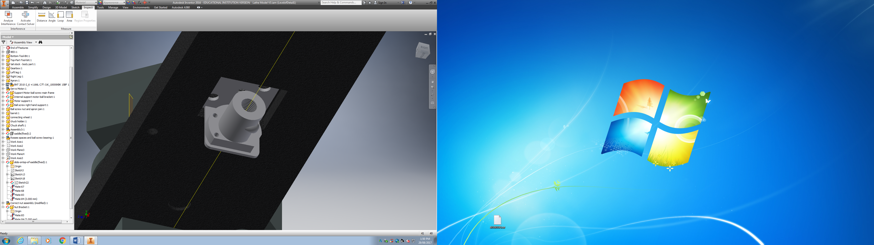

**Nut bracket**

To hold the shaft to the death end an spacer was designed by Ross Jarvis, so we has the worked to make a base support for the motor (appendix 4).

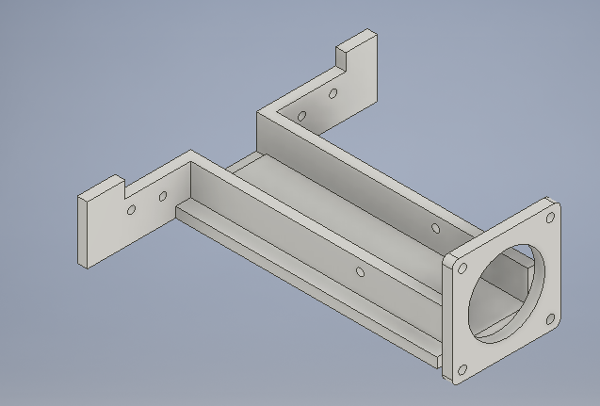

Finally, to hold the gear motor to the shaft we designed a block (appendix 5).

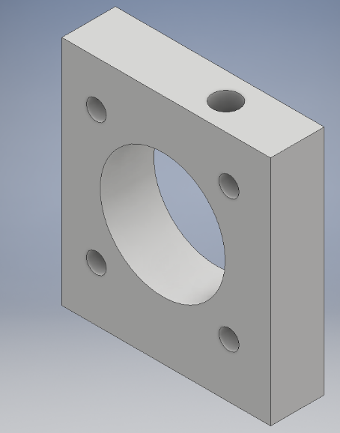

Another important accessory to consider in the assembly of the x-axis shaft is the Flexible Coupling which specifications are 10x8.

**Conclusion**

All the designed part were 3D modelling and assembled together so, I can noticed it was working right or not. At this point in the project, everything looks fine in the 3D modelling. However, it is important to bring out the fact that the support is not probably strong enough to hold the motor weight based in the force analysis (stress), so it is recommendable to do a test in the designed support before installing in the lathe and run it.

# **Recommendations**

It is recommended that the next group that will take over the project, need to check the travel distances, and the dimensions of the supports. So there is no problem in placing and installing the designed parts.

Another recommendation is to analyse much better the stresses in the base support of the motor to double check if it is strong enough to support the weight of the motor.

# **References**

* TSK
* Ocean controls.

# **Appendix**

**Appendix 1. GANTT CHART**



**Appendix 2**

|  |  |  |  |  |  |  |  |  |
| --- | --- | --- | --- | --- | --- | --- | --- | --- |
| **Identify Hazards and subsequent Risks** | **Analyse Risks & Evaluate Risks** | | | **Identify and evaluate existing risk controls** | | | **Further Risk Treatments** | **Standards** |
|
| **Hazards/Issues/Risks** | **Consequence** | **Likelihood** | **Risk level** | **What we are doing now to manage this risk**. | **Effectiveness of our strategies** | **New risk level** | **Further action needed** |
| **Opportunities for improvement** |
| **MECHANICAL** | | | | | | | |  |
| Flying objects such as the chuck key left in chuck | 4 | E | H | Barrier between the workpiece and operator (Protective cover) | Reduces the risk of flying object | L | Voice control | AS 4024.1601-2006 4.6.1(a) , 6.1.3 AS4024.1-1996 (15.3.2.4) |
| Cutting tool injury when cleaning,  filing or polishing (machine off) | 1 | D | L | Risk sign. Authorization | Let people be aware of possible  risk | L | Training | AS 4024.1601-2006 6.3.5, .4.2. 10.2 |
| Metal chips and swarf coming loose | 3 | A | X | Barrier between the workpiece and operator (Protective cover) and the usage of PPE | Reduces the possibility of chips flying out of the machine | L | Voice control | AS 4024.1601-2006 4.6.1(a) |
| Rotating machine parts- entanglement | 5 | E | H | Machine stops when door is open (Mechanical sensor) | Prevent people from getting caught | L | Preventive action | AS 4024.1601-2006 4.6.1(a) AS 4024.1-1996 (15.3.2.3) |
| Closing movements of parts under  power can result finger trapping | 4 | C | X | Machine stops when door is open (Mechanical sensor) | Prevent people from getting caught | L |  | AS 4024.1601-2006 4.6.1(a) AS 4024.1801-2006 |
| Work pieces can very hot | 2 | D | L | Monitoring coolant flow | Assure coolant is running at all time | L | PPE |  |
| Contact with cutting fluids, oil and grease can irritate skin | 1 | B | M | PPE | Prevent skin from contacting fluids | L | PPE | AS 4024.1601-2006 6.1.4 AS 4024.1-1996 (15.4) |
| Swarf can jam the machine or be  ejected if allowed | 1 | E | L | Power protection | Neither motor nor swarf jam have contact with the operator | L | - |  |
| Eye injury | 4 | D | H | Barrier between the workpiece and operator (Protective cover) | Reduces the risk of flying object | L | PPE | AS 4024.1601-2006 4.6.1(a) |
| **ELECTRICAL** | | | | | | | |  |
| Electrocution | 5 | E | H | Check all cables before turning on lathe | Reduce the likelihood of Electrocution | M | Install RCA | AS/NZS 3000:2007 |
| Electric shock | 4 | E | H | Check all cables before turning on lathe | Reduce the likelihood of Electric shock | M | Install RCA | AS/NZS 3000:2007 appendix L |
| Soldering Iron Burns | 2 | C | M | Check the heat from the lathe and training | Lower the risk of damage to person | L | Use Common sense |  |
| Proximity Switch Failure | 3 | D | M | Test switches with lathe off | Assure the function of the switches and replacement of broken switches | L | Recheck switches periodically | AS/NZS 3000:2007 (7.2.2.2) |
| Safety Switches Failure | 3 | D | M | Test switches with lathe off | Assure the function of the switches and replacement of broken switches | L | Recheck switches periodically | AS 4024.1.-1996 (15.3.2.8) |
| Catastrophic Lathe Failure | 4 | E | H | Add an safety stop button | Allows the operator to stop the lathe before catastrophic injury happens | M | PPE | AS 4024.1.-1996 (15.3.2.8) |

**Appendix 3**



**Appendix 4**



**Appendix 5**

